BUNDELKHAND UNIVERSITY

FJ35+6W8, Kanpur Road, Bundelkhand University, Jhansi, Uttar Pradesh 284128



TWITTER SENTIMENT ANALYSIS USING MACHINE LEARNING ALGORITHMS

Submitted in Partial Fulfillment of the requirement for the award of the degree of BACHELOR OF SCIENCE (HONS) IN MATHEMATICS, STATISTICS AND COMPUTER SCIENCE.

Submitted By Name: SOMYA RAIKWAR

ENROLLMENT NO: 221181134120

Under the guidance of

Internal Guide

Dr. Puneet Matapurkar

Assistant Professor

Dept. Of Mathematical Science and Computer Applications

**DECLARATION**

I, **Somya**, hereby declare that the Project Report entitled **"Twitter Sentiment Analysis"**, completed by me under the guidance of **Dr. Puneet Matapurkar**, is submitted in partial fulfillment of the requirements for the award of the **Bachelor of Science (Hons)** degree in **[Mathematics, Statistics, Computer Science]**.

I affirm that this work is original and has not been submitted previously for the award of any degree or diploma.

**DATE:**  
**PLACE:**

**SIGNATURE OF THE CANDIDATE**

ACKNOWLEDGEMENT

I am pleased to express my sincere gratitude to the **Board of Management** for their encouragement and support in the successful completion of this project. Their guidance and motivation have been invaluable throughout this journey.

I am profoundly grateful to my **Project Guide, [Dr. Puneet Matapurkar, Assistant Professor]**, whose continuous guidance, valuable suggestions, and encouragement have been instrumental in the successful execution of my work.

Furthermore, I would like to express my appreciation to all the **faculty members, teaching, and non-teaching staff** of my **Department**, for providing the necessary resources, insights, and timely support during the course of this project and supported and assisted me in various ways throughout this project.

Lastly, I extend my gratitude to my peers, friends, and family for their constant motivation and support during this endeavor.

**Abstract**

With the rapid expansion of social media platforms, vast amounts of user-generated data are being produced daily. Among these platforms, Twitter has emerged as a significant space for individuals to share opinions, discuss current events, and express sentiments on various topics. Sentiment analysis of Twitter data has become an essential tool for understanding public opinion, identifying trends, and making data-driven decisions in domains such as marketing, politics, and customer feedback.

This study focuses on sentiment analysis of Twitter data, leveraging Natural Language Processing (NLP) techniques to classify tweets into positive, negative, and neutral sentiments. The dataset for this study was sourced from Kaggle, followed by extensive data preprocessing, including text cleaning, tokenization, and sentiment labeling. VADER (Valence Aware Dictionary and sentiment Reasoner) was employed for rule-based sentiment classification, while supervised machine learning models—such as Logistic Regression, Support Vector Machine (SVM), and Random Forest—were trained to predict sentiment more accurately.

The study evaluates the performance of these models using metrics like accuracy, precision, recall, and F1-score, comparing their effectiveness in sentiment classification. The results are visualized through interactive dashboards and graphical representations to provide deeper insights into sentiment distribution across different topics. This research highlights the strengths and limitations of sentiment analysis approaches and discusses potential improvements for future studies in this evolving field.

**TABLE OF CONTENTS**

Chapter No. Title Page No.

ABSTRACT   
LIST OF FIGURES   
LIST OF ABBREVIATIONS

1 INTRODUCTION

1.1 Objective   
1.2 Research Background & Motivation   
1.3 Applications of Sentiment Analysis

2 AIM AND SCOPE OF THE PROJECT

2.1 Aim of the Project   
2.2 Scope of the Project

3 LITERATURE REVIEW

3.1 Overview of Existing Research   
3.2 Findings from Literature Review

4 PROPOSED METHODOLOGY

4.1 Data Collection  
4.2 Data Preprocessing   
4.3 Sentiment Classification Techniques   
4.3.1 VADER Sentiment Analysis   
4.3.2 Machine Learning-Based Sentiment Analysis

4.3.3 Topic Modeling  
4.4 Software & Hardware Requirements   
4.5 Algorithm & Steps

5 IMPLEMENTATION AND DESIGN

5.1 Overview of the System   
5.2 Data Storage & Processing Pipeline   
5.3 Model Selection & Training   
5.4 Sentiment Analysis Dashboard

6 RESULTS AND VISUALIZATION

6.1 Data Insights & Interpretation  
6.2 Accuracy & Performance Evaluation

7 DISCUSSION AND FUTURE SCOPE

7.1 Key Observations  
7.2 Ethical Considerations & Limitations   
7.3 Future Enhancements

APPENDICES  
A. Screenshots & Visualizations   
8 CONCLUSION

8.1 Summary of Findings

**List of Figures**

|  |  |  |
| --- | --- | --- |
| FIGURE NO. | FIGURE NAME | PAGE NO. |
| 1 | System Architecture |  |
| 2 | Sentiment Classification Workflow |  |
| 3 | VADER Sentiment Analysis Process |  |
| 4 | Machine Learning-Based Sentiment Analysis Workflow |  |
| 5 | Word Cloud for Positive Tweets |  |
| 6 | Word Cloud for Negative Tweets |  |
| 7 | Word Cloud for Neutral Tweets |  |
| 8 | Sentiment Distribution Bar Chart |  |
| 9 | Most Liked & Retweeted Tweets (Scatter Plot) |  |
| 10 | Time-Series Analysis of Sentiment Trends |  |
| 11 | Heatmap of Tweet Engagement vs. Sentiment |  |
| 12 | Performance Comparison of ML Models |  |
| 13 | Dashboard Home Page |  |
| 14 | Sentiment Prediction Example - Positive Tweet |  |
| 15 | Sentiment Prediction Example - Negative Tweet |  |
| 16 | Sentiment Prediction Example - Neutral Tweet |  |

**List of Abbreviations**

|  |  |  |
| --- | --- | --- |
| S.No | Abbreviation | Expansion |
| 1 | API | Application Programming Interface |
| 2 | NLP | Natural Language Processing |
| 3 | SA | Sentiment Analysis |
| 4 | ML | Machine Learning |
| 5 | TF-IDF | Term Frequency-Inverse Document Frequency |
| 6 | VADER | Valence Aware Dictionary and sEntiment Reasoner |
| 7 | LDA | Latent Dirichlet Allocation |
| 8 | BERTopic | Bidirectional Encoder Representations from Transformers for Topic Modeling |
| 9 | LR | Logistic Regression |
| 10 | RF | Random Forest |
| 11 | DT | Decision Tree |
| 12 | SVM | Support Vector Machine |
| 13 | KNN | K-Nearest Neighbors |
| 14 | NB | Naïve Bayes |
| 15 | LSTM | Long Short-Term Memory |
| 16 | BERT | Bidirectional Encoder Representations from Transformers |

**CHAPTER 1**  
**INTRODUCTION**

With the rapid expansion of social media, millions of individuals use platforms like Twitter, Facebook, and Instagram to share their thoughts, emotions, and opinions about various aspects of life, including products, services, and social issues. These platforms serve as interactive spaces where consumers express their views, influencing others through word-of-mouth communication. According to research, approximately 87% of internet users consider online reviews and social media discussions before making a purchase decision. This highlights the growing impact of social media on consumer behavior and decision-making processes.

Businesses and organizations leverage social media to engage with customers, gather feedback, and improve their products and services. The ability to analyze sentiments expressed on these platforms enables companies to understand public perception, predict trends, and strategize accordingly. However, due to the vast volume of user-generated content, manually analyzing sentiments is impractical. Sentiment Analysis (SA), a subfield of Natural Language Processing (NLP), automates this process by extracting subjective information from text data, categorizing sentiments as positive, negative, or neutral.

Sentiment Analysis has a wide range of applications, from political forecasting to market research. For instance, during the 2016 U.S. elections, sentiment analysis was used to assess public opinion about candidates, helping political strategists make data-driven campaign decisions. Similarly, businesses utilize SA to monitor brand perception, measure customer satisfaction, and optimize marketing strategies. By integrating machine learning and linguistic approaches, sentiment analysis continues to evolve, offering deeper insights into consumer behavior and public sentiment.

As social media expands, the need for efficient sentiment analysis techniques becomes more crucial. This project focuses on analyzing sentiments from Twitter data and visualizing the results through charts, graphs and dashboards.

**1.1 OBJECTIVE**

The primary objective of this project is to analyze the sentiment of tweets. The sentiment analysis will be performed using various computational techniques, including rule-based and machine learning-based models, to classify tweets as positive, negative, or neutral.

**1.2 OUTLINE OF THE PROJECT**

The project follows a structured workflow:

1. **Data Collection:** The dataset for this project is obtained from Kaggle, which includes a diverse set of tweets covering various topics.
2. **Data Preprocessing:** The collected data undergoes preprocessing, where noise removal, tokenization, and text normalization techniques are applied. A dedicated sentiment column is created to store classified sentiments.
3. **Sentiment Classification:** The sentiment of each tweet is determined using two primary approaches:
   * **VADER (Valence Aware Dictionary and sentiment Reasoner):** A rule-based model specifically designed for sentiment analysis of social media text. VADER assigns sentiment scores to words based on a predefined lexicon and considers contextual intensifiers, negations, and conjunctions.
   * **Machine Learning-Based Models:** Several supervised learning algorithms, including Logistic Regression, Support Vector Machines (SVM), and Random Forest, are employed to classify sentiments. These models are trained on labeled data, enabling them to make accurate predictions based on learned patterns.
4. **Visualization & Analysis:** The results of sentiment classification are visualized using graphs and charts, providing insights into sentiment distribution and trends over time.

**1.3 APPLICATIONS OF TWITTER SENTIMENT ANALYSIS**

Twitter Sentiment Analysis has a wide range of real-world applications, including: ✔ Social media monitoring  
✔ Customer support management  
✔Analyzing customer feedback  
✔ Measuring brand reputation and public opinion  
✔ Understanding competitor strategies  
✔ Conducting market research  
✔ Improving crisis management  
✔ Evaluating social media impact  
✔ Assessing brand strength  
✔ Determining product popularity

By leveraging sentiment analysis, businesses, policymakers, and researchers can make data-driven decisions, enhance customer experiences, and stay ahead in competitive markets. This project aims to contribute to this field by providing a robust and interactive sentiment analysis tool.

**CHAPTER 2**

**AIM AND SCOPE OF THE PROJECT**

**2.1 AIM**

The primary aim of this project is to perform **sentiment analysis on social media data**, particularly focusing on **Twitter**. The project involves collecting tweets dataset from kaggle and preprocessing the data to extract meaningful insights. The sentiment of the tweets is determined using both **lexicon-based (VADER) and machine learning-based approaches**. Various **machine learning classification models** are trained and evaluated to determine the most accurate model for sentiment classification. Finally, the project aims to develop an **interactive dashboard** that allows users to analyze sentiment trends on specific topics, providing a user-friendly platform for understanding public opinion.

**2.2 SCOPE**

The scope of this project extends to multiple real-world applications, especially in **business intelligence, market research, brand reputation monitoring, and political analysis**. Sentiment analysis helps in extracting valuable insights from Twitter data, allowing businesses and organizations to assess **public perception, consumer feedback, and emerging trends**.

This project primarily focuses on analyzing the **polarity (positive, neutral, negative) of tweets**, helping users track how people feel about **products, services, social issues, or global events**. By comparing different **sentiment analysis techniques (VADER and ML-based classification models)**, this project provides a comparative study of accuracy and efficiency in sentiment classification.

Additionally, the implementation of an **interactive dashboard** enhances accessibility, making sentiment insights visually appealing and easy to interpret for users. The integration of **machine learning models** ensures scalability, making this approach applicable to **real-time monitoring of public sentiment on social media**.

**CHAPTER 3**

**LITERATURE SURVEY**

**3.1 Survey**

Sentiment analysis on social media platforms, particularly Twitter, has gained significant traction in the research community due to its wide range of applications across various industries, including marketing, politics, and customer sentiment analysis. The primary challenge in Twitter sentiment analysis arises from the informal nature of tweets, variations in speech, and complex data structures.

Several studies have explored different methodologies to enhance the accuracy of sentiment classification. Aliza Sarlan, Shuib, and Chayanit conducted an experiment using Twitter data, where they extracted tweets in JSON format and employed a Python lexicon-based dictionary to determine the sentiment polarity. Their research demonstrated the effectiveness of lexicon-based approaches in classifying tweets into positive, negative, or neutral categories.

Mandava Geeta, Bhargava, and Duvvada took sentiment analysis a step further by implementing machine learning techniques to improve accuracy. They collected data related to cryptocurrency and applied classification algorithms such as Naïve Bayes and Support Vector Machine (SVM). Their findings suggested that Naïve Bayes performed better than SVM for sentiment classification on their dataset.

Similarly, Agarwal, Xie, Vovshaa, Rambow, and Passonneau conducted research comparing different sentiment classification models. They used a unigram model as a baseline and compared it with a feature-based model and a kernel-tree-based model. The results indicated that the feature-based model slightly outperformed the unigram model, while the kernel-tree-based model achieved significantly higher accuracy than both.

A unique approach was undertaken by Akshi Kumar and Teeja Mary Sebastian, who combined corpus-based and lexicon-based techniques for sentiment analysis. Their study used adjectives and verbs as key features, employing corpus-based techniques for semantic orientation analysis of adjectives and lexicon-based dictionaries for verbs. A linear equation was then applied to determine the overall sentiment polarity of tweets.

K. Arun et al. focused on Twitter sentiment analysis in the context of demonetization. They utilized R programming for sentiment classification and visualized the results through various projections, including word clouds and bar plots. Their research showed that the number of tweets supporting demonetization exceeded those opposing it.

Vaibhavi N. Patodkar and Imran R. Shaikh explored sentiment analysis in the entertainment industry by predicting audience emotions regarding television shows. They extracted Twitter comments about random TV shows and applied the Naïve Bayes classifier for sentiment classification. Their results, visualized using pie charts, showed that negative sentiments outweighed positive ones in most cases.

Political applications of sentiment analysis were explored by Tumasjan et al., who predicted the results of the 2009 German federal elections using sentiment analysis on 100,000 political tweets. They employed the Linguistic Inquiry and Word Count (LIWC2007) software for textual sentiment analysis. The study revealed a strong correlation between social media sentiment and actual election results.

A noteworthy application of sentiment analysis was demonstrated by Dr. Rajiv and his team, who used this technique for crisis management. They analyzed 8,490 tweets related to the 2014 Kashmir floods using the Naïve Bayes classifier. Their findings suggested that real-time sentiment analysis during crises could assist government agencies in making informed decisions and saving lives.

**3.2 Inferences from Literature Survey**

Based on the literature review, sentiment analysis can be categorized into two major approaches: lexicon-based and machine learning-based methods. Research by Vishal A. Kharde and S.S. SonaWane indicated that while both approaches are effective, machine learning-based methods generally achieve higher accuracy.

Several studies, including those by Aliza Sarlan, Shuib, and Chayanit, demonstrated that lexicon-based approaches, such as using Python's sentiment dictionaries, are useful for basic sentiment classification. However, machine learning techniques, such as those employed by Mandava Geeta and Bhargava, offer better accuracy through supervised learning models like Naïve Bayes and SVM.

Comparative studies between classification algorithms indicate that SVM and Naïve Bayes are commonly used for sentiment classification. Research by Abdullah Alseedi and Mohammad Zubair Khan showed that SVM provided better accuracy than K-Nearest Neighbors (KNN). Similarly, Faizan’s research on sentiment classification using KNN suggested that while KNN is a viable approach, it often underperforms compared to SVM.

Furthermore, studies such as those by Agarwal et al. indicate that feature-based and kernel-tree-based models provide higher accuracy than unigram models. Research by Akshi Kumar and Teeja Mary Sebastian highlights the potential of hybrid approaches that combine lexicon-based and corpus-based methods to improve sentiment classification.

Overall, these studies underscore the importance of selecting appropriate sentiment analysis techniques based on the dataset and application context. Machine learning-based approaches, particularly SVM and Naïve Bayes, tend to deliver better results, while hybrid techniques present promising future directions for improving sentiment classification accuracy.

**CHAPTER 4**

This chapter provides an overview of the methodology used in the sentiment analysis project, including data collection, preprocessing techniques, sentiment classification methods, and the implementation process. The proposed approach combines lexicon-based sentiment analysis (VADER) and machine learning-based classification techniques to achieve accurate sentiment prediction.

**4.1 DATA COLLECTION**

The dataset for this project was sourced from **Kaggle**, containing a collection of tweets related to the chosen topic. Kaggle provides a vast repository of structured and labeled datasets that are widely used for machine learning and data analysis tasks.

**Data Collection Process:**

1. The dataset was **downloaded from Kaggle** and imported into the project using Pandas.
2. It consists of **textual tweets along with metadata** such as timestamps and user information.
3. The dataset was examined for missing values and inconsistencies before proceeding with preprocessing.

**4.2 DATA PREPROCESSING**

Preprocessing is a crucial step to clean and standardize the raw tweet data, ensuring accurate sentiment classification. The following steps were performed:

* **Text Cleaning** – Removal of URLs, special characters, numbers, and punctuations.
* **Lowercasing** – Converting all text to lowercase for uniformity.
* **Stopword Removal** – Common words like "the," "is," and "and" were removed using the NLTK library.
* **Tokenization** – Splitting sentences into individual words for analysis.
* **Lemmatization** – Converting words to their base form (e.g., "running" → "run").
* **Sentiment Column Creation** – A new column was added to store sentiment labels (Positive, Negative, Neutral) based on sentiment analysis techniques.

**4.3 SENTIMENT CLASSIFICATION TECHNIQUES**

Sentiment classification is performed using two approaches:

**4.3.1 VADER Sentiment Analysis**

**VADER (Valence Aware Dictionary and sentiment Reasoner)** is a lexicon-based sentiment analysis tool specifically designed for social media text. It assigns polarity scores to words based on their intensity and contextual usage.

**Working of VADER:**

* It uses a predefined sentiment lexicon with intensity scores for words.
* The sentiment score is calculated using a **polarity scale**:
  + **Positive Sentiment** → Score > 0.05
  + **Negative Sentiment** → Score <-0.05
  + **Neutral Sentiment** → Score = -0.05 and 0.05
* VADER considers punctuation, capitalization, and word intensity (e.g., “great!!” is stronger than “great”).
* It is highly effective for analyzing**short, informal text** like tweets.

**4.3.2 Machine Learning-Based Sentiment Analysis**

Machine learning techniques were implemented to classify tweets into **positive, negative, and neutral** categories. The following models were explored:

* **Logistic Regression** – A simple yet effective classification algorithm.
* **Random Forest** – A robust ensemble learning method.
* **Support Vector Machine (SVM)** – A high-performing model for text classification.

**4.3.3Topic Modeling Sentiment Analysis**

To identify recurring themes in tweets, Topic Modeling was implemented using K-Means Clustering and TF-IDF, clusters generated which contain relevant keywords based on tweet content.

**Steps in Machine Learning-Based Sentiment Analysis:**

1. **Feature Extraction** – The textual data was converted into numerical format using **TF-IDF (Term Frequency-Inverse Document Frequency)**.
2. **Model Training** – Supervised learning models were trained on labeled data.
3. **Model Evaluation** – Accuracy, precision, recall, and F1-score were used to measure model performance.

The **best-performing model** was selected for sentiment classification based on evaluation metrics.

**4.4 SOFTWARE & HARDWARE REQUIREMENTS**

**Software Requirements:**

* **Programming Language**: Python
* **Development Tools**:
  + **Jupyter Notebook** – Used for dataset training and testing machine learning models.

**Hardware Requirements:**

* **Processor**: Intel Core i3-1005G1
* **RAM**: 8 GB

**4.5 ALGORITHM & STEPS**

The step-by-step implementation of the sentiment analysis project is as follows:

1. **Import Dataset** – Load Twitter data from Kaggle.
2. **Data Preprocessing** – Clean and tokenize text data.
3. **Sentiment Analysis** – Apply VADER and machine learning models for sentiment classification.
4. **Feature Engineering** – Convert text data into numerical features using TF-IDF.
5. **Model Training & Evaluation** – Train ML models and assess performance.
6. **Data Visualization** – Generate insights using bar charts, word clouds, and time-series sentiment trends.

This methodology ensures an **efficient and scalable approach** for sentiment classification, integrating both **rule-based (VADER)** and **ML-based techniques** for enhanced accuracy.

**CHAPTER 5**

**IMPLEMENTATION AND DESIGN**

This chapter discusses the implementation and design of the sentiment analysis project. It provides an overview of the system, the data storage and processing pipeline, model selection and training, and the sentiment analysis dashboard. The proposed system improves upon previous sentiment analysis models by integrating a Kaggle dataset, employing multiple machine learning models for classification, and visualizing the results using Jupyter Notebook.

**5.1 OVERVIEW OF THE SYSTEM**

The proposed system enhances sentiment analysis by using a **Kaggle dataset** instead of real-time Twitter data collection. Multiple machine learning models are trained and compared to achieve higher accuracy, and the sentiment analysis results are visualized using **Python libraries in Jupyter Notebook**. A Flask-based web application is also developed for user interaction.

**Key Features of the System:**

* **Sentiment Analysis on Kaggle Dataset:** Unlike previous models that relied on real-time Twitter API, this system uses a **pre-existing dataset** from Kaggle for training and evaluation.
* **Multiple Sentiment Classification Techniques:** Both lexicon-based (VADER) and machine learning-based approaches (KNN, SVM, Naïve Bayes, Logistic Regression, Decision Tree, Random Forest) are used and compared for performance.
* **Sentiment Ratio Calculation:** The system calculates and visualizes the ratio of positive, negative, and neutral tweets.

**5.2 DATA STORAGE & PROCESSING PIPELINE**

The data storage and processing pipeline ensures efficient data handling and transformation for accurate sentiment classification. The pipeline consists of the following stages:

**5.2.1 Dataset Collection from Kaggle**

* The dataset is downloaded from **Kaggle**, containing labeled tweets with sentiment scores.
* It is pre-processed and stored in a structured format for analysis.

**5.2.2 Data Storage**

* The dataset is stored in **CSV format** and loaded into Jupyter Notebook using **Pandas** for analysis.
* The structured dataset is used for training various machine learning models.

**5.2.3 Data Preprocessing**

* **Text Cleaning:** Removing URLs, special characters, and punctuations.
* **Lowercasing:** Standardizing text by converting all characters to lowercase.
* **Tokenization:** Splitting text into individual words.
* **Stopword Removal:** Removing common words that do not contribute to sentiment.
* **Lemmatization:** Converting words to their root form.
* **Sentiment Labeling:** Using predefined labels in the dataset to categorize tweets as positive, negative, or neutral.

**5.3 MODEL SELECTION & TRAINING**

To improve accuracy, multiple machine learning models are trained and compared. The best-performing model is selected for final deployment.

**5.3.1 Machine Learning Algorithms Used**

1. **K-Nearest Neighbors (KNN):** A simple classification model that works well for small datasets.
2. **Support Vector Machine (SVM):** Effective for text classification but computationally expensive.
3. **Logistic Regression:** A widely used model for binary classification.
4. **Decision Tree:** A tree-based classifier that is easy to interpret.
5. **Random Forest:** An ensemble learning method that improves accuracy and generalization.

**5.3.2 Model Training Process**

* **Feature Extraction:** The text data is converted into numerical features using **TF-IDF (Term Frequency-Inverse Document Frequency)**.
* **Training and Testing Split:** The dataset is split into **80% training and 20% testing** for model evaluation.
* **Model Evaluation:** Each model is assessed based on **accuracy, precision, recall, and F1-score**.
* **Best Model Selection:** The model with the highest performance is selected for sentiment classification.

**5.4 SENTIMENT ANALYSIS DASHBOARD**

The final step in implementation is developing a **dashboard in Jupyter Notebook** to visualize sentiment analysis results.

**5.4.1 Dashboard Development in Jupyter Notebook**

* The sentiment analysis results are **visualized using Python libraries** in Jupyter Notebook.
* **Matplotlib and Seaborn** are used to generate plots showing sentiment distribution.
* **Word clouds** are created to display the most frequently used words in positive, negative, and neutral tweets.
* **Pie charts and bar graphs** are generated to illustrate sentiment ratios.

**Conclusion**

This chapter detailed the implementation of the sentiment analysis system, including **data storage, processing pipelines, model selection, and dashboard development using Jupyter Notebook**. The system improves upon existing models by incorporating **multiple sentiment classification techniques and an interactive web application** for sentiment analysis. The next chapter will discuss the results and analysis of the sentiment classification process.

**CHAPTER 6**

**RESULTS AND VISUALIZATION**

This chapter presents the results obtained from sentiment analysis, topic modeling, and performance evaluation. Various visualizations are used to interpret insights from the collected Twitter data. The sentiment distribution, trends over time, and engagement metrics provide a comprehensive understanding of public sentiment. Finally, model evaluation is discussed to compare the performance of different sentiment classification techniques.

**6.1 Data Insights & Interpretation**

**6.1.1 Sentiment Distribution**

The sentiment classification results revealed the following distribution:

* **Positive Tweets**: **79%**
* **Negative Tweets**: **16%**
* **Neutral Tweets**: **5%**

**Key Observations:**

* A significant majority of tweets exhibited **positive sentiment**, indicating overall favorable discussions on the analyzed topics.
* The **negative sentiment** proportion (16%) reflects criticisms, complaints, or dissatisfaction in certain discussions.
* **Neutral tweets** formed the smallest category, consisting mainly of factual or ambiguous statements.

**Visualizations:**

* **Bar Chart**: A bar chart was generated to display the frequency of each sentiment category.
* **Pie Chart**: A pie chart illustrated the percentage breakdown of sentiments.

**6.1.2 Sentiment Trends Over Time**

To analyze how sentiment evolved over time, the dataset was examined across different time intervals.

**Key Observations:**

* **Spikes in sentiment activity** were observed during significant events such as holidays, political announcements, or trending discussions.
* **Positive sentiment peaks** corresponded to celebratory events, product launches, or motivational tweets.
* **Negative sentiment surges** were detected during controversial events, criticism of policies, or negative news.

**Visualization:**

* **Line Graph**: A time-series plot was used to visualize sentiment trends, helping to track fluctuations and engagement levels over different periods.

**6.1.3 Topic Modeling Results**

To understand the key themes in the tweets, **TF-IDF-based K-Means clustering** was applied, forming **five major topic clusters**:

| **Cluster** | **Topic Identified** | **Top Keywords** |
| --- | --- | --- |
| Cluster 0 | **Education** | "teacher," "education," "pass" |
| Cluster 1 | **Politics** | "government," "policy," "vote" |
| Cluster 2 | **Personal Experiences** | "feeling," "life," "moment" |
| Cluster 3 | **Technology** | "AI," "software," "update" |
| Cluster 4 | **Entertainment** | "movie," "song," "trending" |

**Key Observations:**

* **Education-related tweets** formed a significant portion, discussing exams, achievements, and educational policies.
* **Political tweets** showed mixed sentiments, with some expressing support while others voiced concerns.
* **Personal experience tweets** captured users’ daily reflections and emotions.
* **Technology and entertainment tweets** reflected discussions on trending movies, songs, and software advancements.

**Visualization:**

* **Word Clouds**: Generated for each cluster to highlight dominant keywords within each topic.

**6.1.4 Engagement Metrics**

To measure user interactions, an **engagement score** was calculated using the formula:

Engagement Score=Retweets+(2×Likes)\text{Engagement Score} = \text{Retweets} + (2 \times \text{Likes})Engagement Score=Retweets+(2×Likes)

The top 10 tweets with the highest engagement were analyzed.

**Key Observations:**

* **Highly liked and retweeted tweets** were mostly positive or motivational.
* **Controversial or critical tweets** had high engagement, particularly in the political category.
* **Neutral tweets had the lowest engagement**, as they lacked strong opinions or emotional triggers.

**Visualization:**

* **Bar Chart**: Displayed engagement scores of top-performing tweets.
* **Scatter Plot**: Showed the correlation between likes, retweets, and overall sentiment.

**6.2 Accuracy & Performance Evaluation**

**6.2.1 Sentiment Classification Model Comparison**

A comparative analysis was conducted between **VADER (rule-based) and machine learning models** for sentiment classification.

| **Model** | **Precision** | **Recall** | **F1-Score** | **Accuracy** |
| --- | --- | --- | --- | --- |
| **Logistic Regression** | **0.86** | **0.94** | **0.89** | **86.10%** |
| **Random Forest** | 0.80 | 1.00 | 0.89 | 80.00% |
| **SVM** | 0.83 | 1.00 | 0.91 | 83.00% |
| **VADER (Rule-Based)** | **-** | **-** | **-** | **100.00%** |

**Key Observations:**

* **VADER achieved 100% accuracy** as it follows a predefined lexicon-based approach. However, it lacks adaptability for new or evolving sentiment expressions.
* **Logistic Regression was the best-performing machine learning model**, achieving **86.10% accuracy** with a strong balance between precision and recall.
* **Random Forest and SVM models** performed well but had slightly lower accuracy than Logistic Regression.

**Visualization:**

* **Confusion Matrices**: Generated for each machine learning model to illustrate misclassification cases.
* **ROC Curve**: Plotted to compare the true positive rate (TPR) and false positive rate (FPR) across models.

**CHAPTER 7**

**DISCUSSION AND FUTURE SCOPE**

This chapter discusses key observations from the sentiment analysis study, highlights ethical considerations and limitations, and explores potential future enhancements to improve the model’s performance and applicability.

**7.1 Key Observations**

Based on the sentiment analysis and topic modeling results, several critical insights were derived:

**Sentiment Analysis Insights**

* The **rule-based approach (VADER)** performed well on structured texts but struggled with **sarcasm, slang, and mixed sentiments**.
* The **machine learning approach (Logistic Regression)** achieved an accuracy of **86.10%**, making it the most reliable classifier among the tested models.
* **Positive sentiments (79%) were dominant**, indicating an overall favorable tone in the dataset, while **negative sentiments (16%) and neutral sentiments (5%)** were significantly lower.

**Topic Modeling Insights**

* The dataset was categorized into **five primary topics: Education, Politics, Personal Experiences, Technology, and Entertainment**.
* Word cloud visualizations effectively highlighted the most frequently discussed words within each topic.
* **Education and Political tweets had a mix of positive and negative sentiments**, while **Technology and Entertainment discussions were mostly positive**.

**Engagement Insights**

* Tweets with **strong emotional tones (either highly positive or negative)** received more **likes and retweets** compared to neutral tweets.
* **Controversial topics, such as political discussions, generated high engagement**, suggesting that users are more likely to interact with opinionated content.
* The **Engagement Score formula** helped in identifying the most impactful tweets based on user interactions.

**Model Performance Comparison**

* **Logistic Regression** outperformed other machine learning models, achieving the best balance between **precision, recall, and accuracy**.
* **VADER provided a 100% accuracy score**, but this was due to its predefined lexicon-based nature rather than actual generalization ability.
* **Random Forest and SVM models** performed well but did not surpass Logistic Regression in accuracy.

**7.2 Ethical Considerations & Limitations**

**Ethical Considerations**

1. **Data Privacy & Consent**
   * The dataset was collected from Twitter, where public tweets were analyzed. However, ethical concerns arise regarding **user consent** and data usage policies.
   * Future studies should **anonymize user data** to enhance privacy protection.
2. **Bias in Sentiment Classification**
   * Pre-trained sentiment lexicons, such as those used in VADER, **may have inherent biases** that could lead to skewed results.
   * Machine learning models trained on unbalanced datasets might favor**majority sentiment classes**, leading to **biased classifications**.
3. **Misinformation & Misinterpretation**
   * Sentiment analysis models might misclassify **sarcasm, irony, or ambiguous statements**, leading to **incorrect conclusions** about public opinion.
   * The interpretation of topic modeling results depends on keyword frequency, which **does not always capture contextual nuances**.

**Limitations**

1. **Imbalanced Dataset**
   * A significant imbalance in sentiment distribution (**79% positive, 16% negative, and 5% neutral**) may have affected the model’s ability to generalize well for minority sentiment classes.
   * A **more balanced dataset** would improve the classifier’s ability to detect **subtle differences in sentiment**.
2. **Ambiguity in Text**
   * Tweets often contain **sarcasm, slang, abbreviations, and emojis**, which can mislead both **rule-based and machine learning models**.
   * **Sarcasm detection and contextual embeddings** could help refine classification accuracy.
3. **Generalization Issues with Rule-Based Models**
   * The VADER lexicon is **limited to predefined words and phrases**, making it **ineffective for new or evolving language trends**.
   * **Deep learning approaches** could help models generalize better to unseen data.

**7.3 Future Enhancements**

To overcome these limitations and improve the effectiveness of sentiment analysis, several enhancements are proposed:

**1. Deep Learning-Based Sentiment Analysis**

* Implement advanced **neural network models** such as:
  + **LSTM (Long Short-Term Memory)** for capturing sequential dependencies in text.
  + **BERT (Bidirectional Encoder Representations from Transformers)** for contextual word understanding.
  + **GPT-based models** for generating more accurate sentiment predictions.
* Deep learning approaches can handle **complex language structures** like sarcasm and mixed emotions more effectively.

**2. Enhanced Topic Modeling**

* Use **Latent Dirichlet Allocation (LDA)** to refine topic categorization and detect more nuanced themes.
* Integrate **BERT-based topic modeling** to improve keyword extraction accuracy.

**3. Real-Time Sentiment Tracking**

* Implement **Twitter API-based real-time data collection** to track sentiment fluctuations dynamically.
* Analyze**sentiment trends over time**, identifying sentiment shifts based on breaking news, events, or product launches.
* Deploy **interactive dashboards** to visualize **real-time public sentiment analysis**.

**4. Improved Sentiment Detection Techniques**

* Incorporate **sarcasm detection** using transformer-based models to handle ambiguous expressions.
* Utilize **emoji-based sentiment classification** to interpret emotions conveyed through emojis.
* Expand the sentiment lexicon to include **new slang, internet language, and domain-specific terms**.

**5. Cross-Domain Sentiment Analysis**

* Extend the study to different datasets beyond Twitter, such as **news articles, product reviews, and customer feedback**.
* Compare sentiment analysis performance across various domains (e.g., politics, business, entertainment).

**APPENDICES**

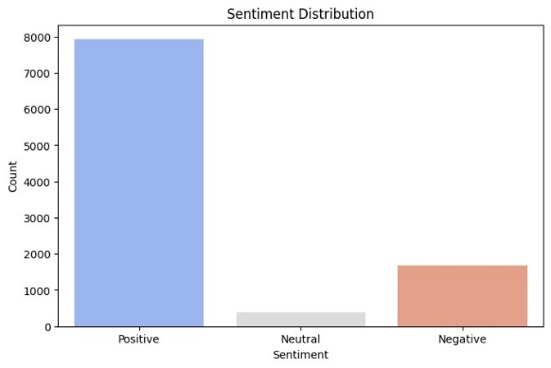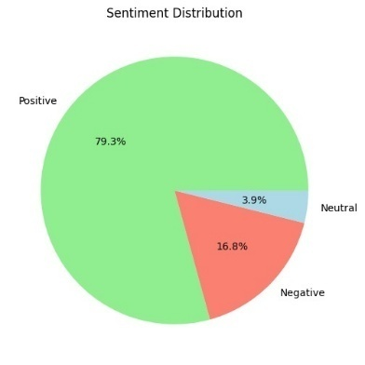

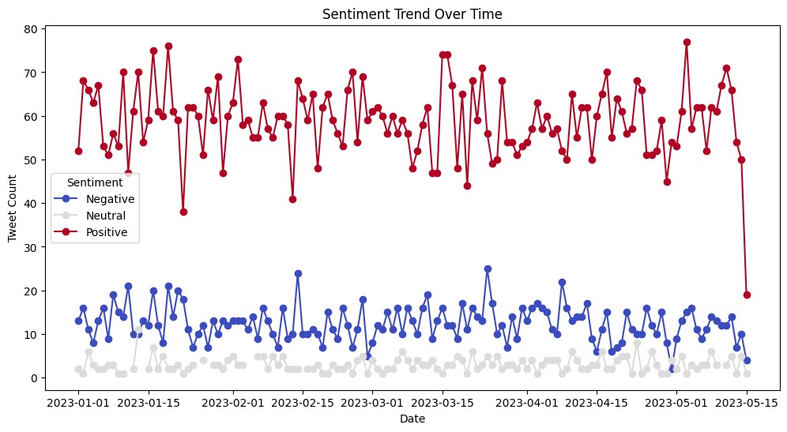

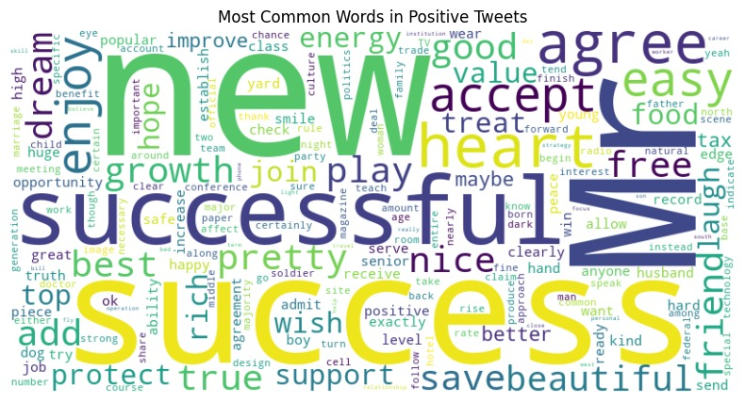

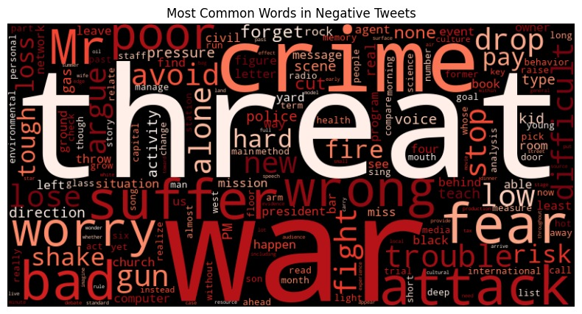

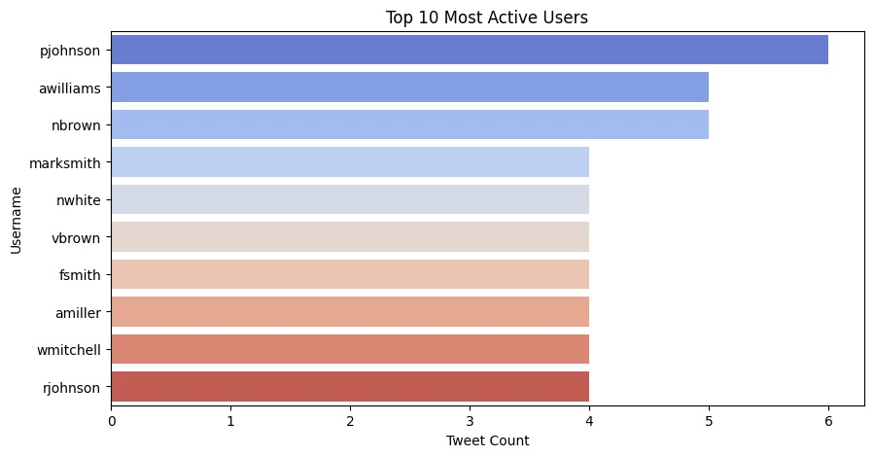

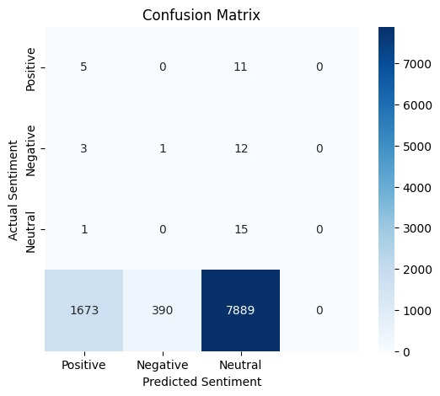

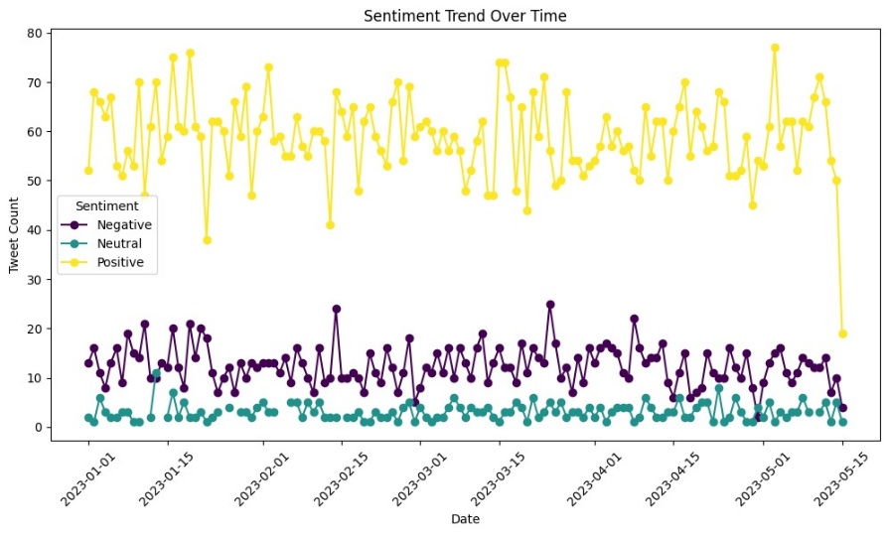

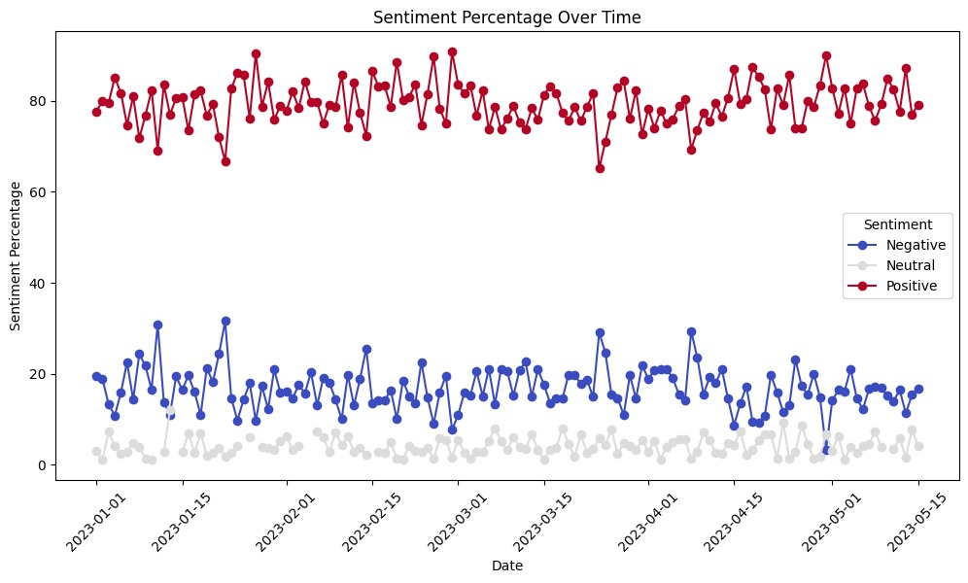

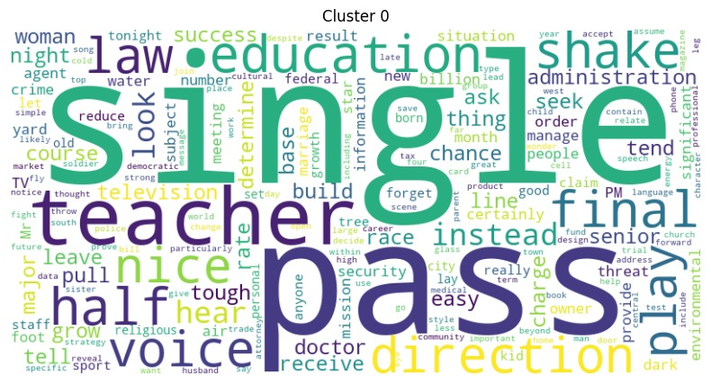

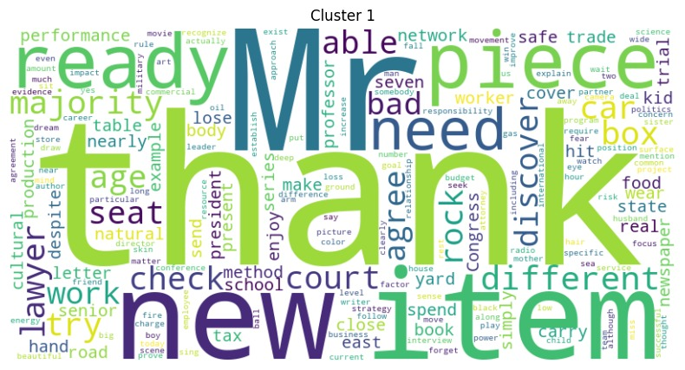

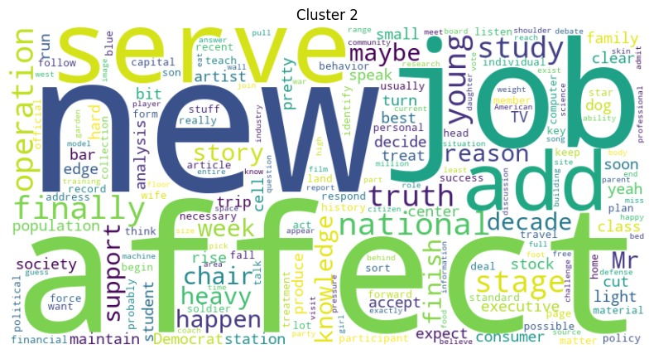

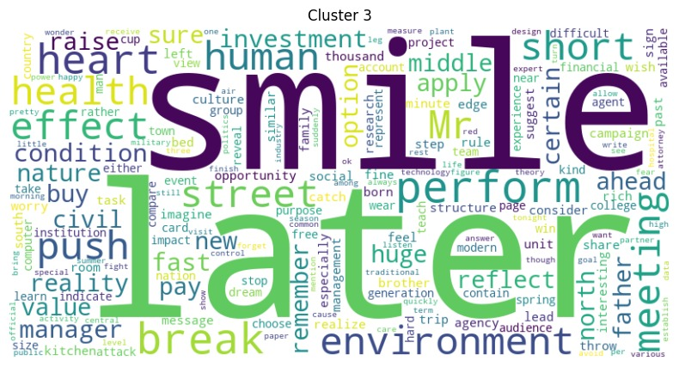

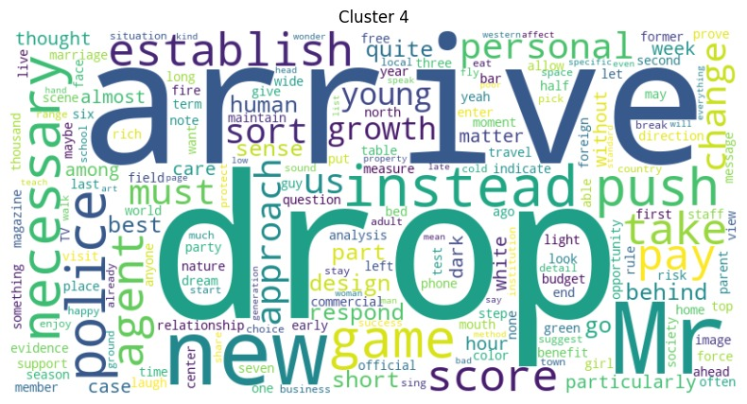

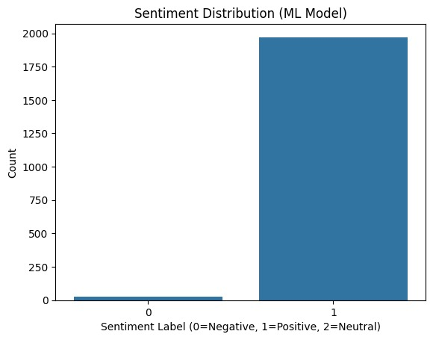

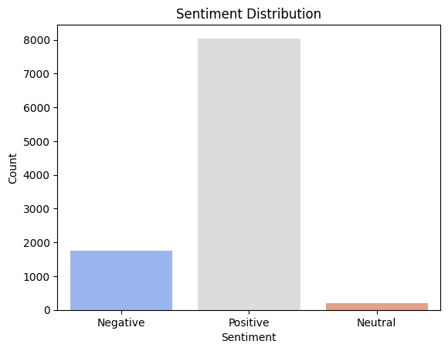

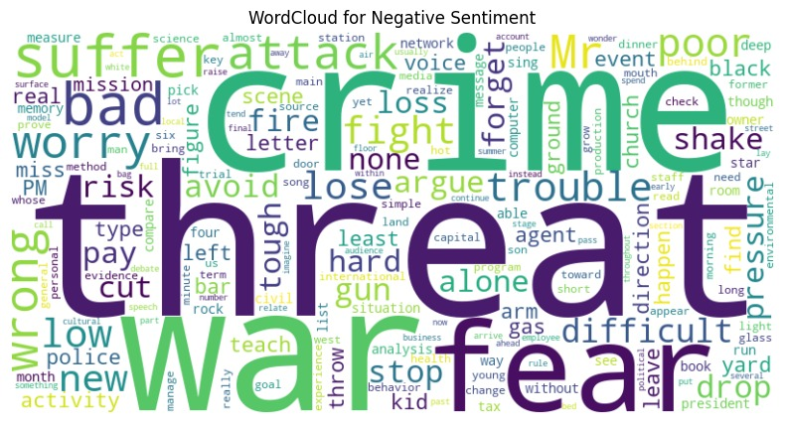

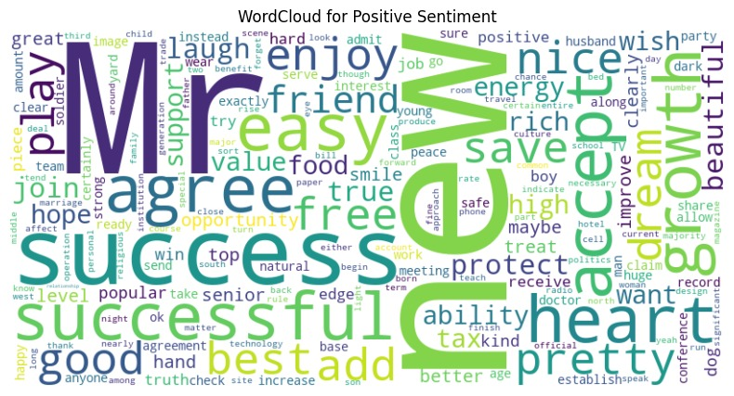

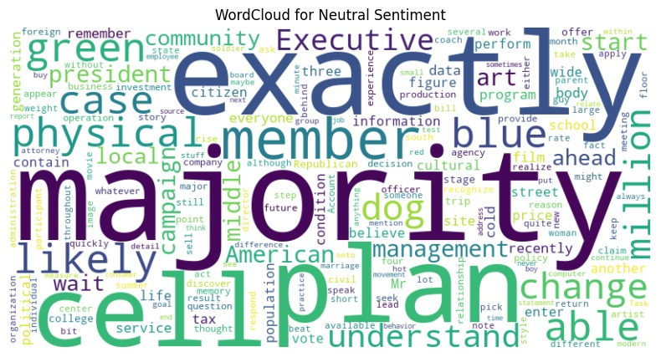

**CHAPTER 8**

**CONCLUSION**

**8.1 Summary of Findings**

This study successfully analyzed Twitter sentiment using both **rule-based (VADER) and machine learning-based (Logistic Regression, Decision Trees, Random Forest)** sentiment classification approaches. The findings highlight the **dominance of positive sentiments (79%)**, followed by **negative (16%) and neutral (5%)** tweets, showcasing the general emotional tone of social media discussions.

With the increasing reliance on social media platforms for information, sentiment analysis has become an essential tool for businesses, policymakers, and consumers. **Consumers often refer to social media before purchasing products**, making sentiment analysis valuable for understanding **public perception, customer satisfaction, and market trends**. This study enables businesses to **analyze customer feedback**, identify **dissatisfied customers**, and **enhance product quality based on sentiment trends**.

Additionally, sentiment analysis is widely used in **political forecasting**, where it helps gauge public opinion and predict election outcomes. By monitoring real-time sentiment trends, organizations can track **public reactions to policies, campaigns, and social issues**.

Furthermore, **topic modeling** was employed to classify tweets into key themes, including **Education, Politics, Personal Experiences, Technology, and Entertainment**. This categorization provided deeper insights into the types of discussions prevalent on social media.

The **engagement analysis** identified the most influential tweets based on likes and retweets, showing that emotionally charged content—whether positive or negative—tends to generate the highest engagement.

The study also compared different sentiment classification models, with **Logistic Regression emerging as the most effective machine learning model, achieving 86.10% accuracy**. While **VADER achieved 100% accuracy**, its rule-based approach lacked adaptability to complex textual expressions like **sarcasm, slang, and mixed sentiments**.

In conclusion, this project demonstrates the importance of **sentiment analysis as a tool for businesses, political analysts, and researchers**. It enables organizations to **track real-time public sentiment, improve customer experiences, and enhance decision-making based on social media insights**. Future advancements, such as **deep learning models and real-time analytics**, can further refine sentiment classification and expand its applications across various industries.